|  |  |  |
| --- | --- | --- |
| WIEiT | Circuit Theory II Laboratory | 2.05.2023 |
| E&T1 | **NODAL ANALYSIS** |  |
| Sekcja IV | Maciej Zduniak  Gabriel Ćwiek  Serhii Hamretskyi |  |

1. Equipment:
2. Dedicated evaluation board having programmable function generator
3. Vector voltmeter
4. Oscilloscope
5. Given PCB RLC circuits (b) & (d))
6. Course of the exercise:
7. Arranging the evaluation board with function generator, the vector voltmeter and the oscilloscope with the RLC circuits. The output of the vector voltmeter – AKA. the evaluation board was connected with a coaxial cable to the input of each circuit. Hence we get a complete circuit containing the source. The first channel of the voltmeter was connected directly to the voltage source. Such feedback sets a reference waveform for the voltmeter. The second channel was used to measure node voltages in contemporarily circuit using an oscilloscope test probe
8. Analyzing and measuring the node voltages across each marked points (1, 2, 3, 4 / Va, Vb, Vc, Vd) using the oscilloscope in the laboratory
9. Documenting the results as exponential complex values of voltages at nodes
10. Analyzing the circuit on paper, using Nodal Analysis
11. Analyzing the circuit in Mathlab
12. Analyzing the circuit in a analytic software – <https://www.Multisim.com>.
13. Results of measurements:

|  |  |  |  |  |  |  |
| --- | --- | --- | --- | --- | --- | --- |
| Measurement pt. freq = 4kHz | Pt. B | mV | Angle (deg.) | Pt. D | mV | Angle (deg.) |
| 1 | 386 | | 0 | 392 | | 0 |
| 2 | 112 | | .5 | 384 | | -2.3 |
| 3 | 127 | | 24 | 315 | | 0.5 |
| 4 | 271 | | -.5 | 364 | | -1 |

|  |  |  |  |  |  |  |
| --- | --- | --- | --- | --- | --- | --- |
| Measurement pt. freq = 6kHz | Pt. B | mV | Angle (deg.) | Pt. D | mV | Angle (deg.) |
| 1 | 340 | | 0 | 391 | | 0 |
| 2 | 116 | | -188 | 390 | | -4 |
| 3 | 290 | | 85 | 302 | | 0.5 |
| 4 | 465 | | 465 | 329 | | -2 |

|  |  |  |  |  |  |  |
| --- | --- | --- | --- | --- | --- | --- |
| Measurement pt. freq = 8kHz | Pt. B | mV | Angle (deg.) | Pt. D | mV | Angle (deg.) |
| 1 | 345 | | 0 | 389 | | 0 |
| 2 | 244 | | 91 | 396 | | -8 |
| 3 | 425 | | 29.5 | 273 | | 3 |
| 4 | 228 | | -111 | 546 | | -5 |

1. Analyzing the circuit on paper
2. We rewrite the specifications of components into more manageable numbers
3. We calculate the angular velocity from the frequency
4. We determine the value of sinusoidal voltage source from exponential complex number to trigonometric complex number containing the angular velocity
5. We determine the value of sinusoidal voltage out the source in algebraic complex number.
6. We calculate the impedance of each resistive component
7. Using Nodal analysis and given in the excel table: node voltages we write the equation for value of current passing through the examined element (Coil L21 and Capacitor C42)
8. We calculate the algebraic value of the flowing current
9. We calculate the Root mean square value of the flowing current
10. WARNING! In the calculations we determined the value of the current as the difference of node voltages divided by the impedance of the resistive element. THIS IS THE EASY WAY OUT, as calculating the current regularly only using the voltage given on the voltage source CERTAINLY leads to high value errors and almost certain mistakes in calculations, leaving us with a completely ambiguous results.

* Below you can see the calculations performed for the first frequency (4kHz) for respectively: the L21coil and the C42 capacitor

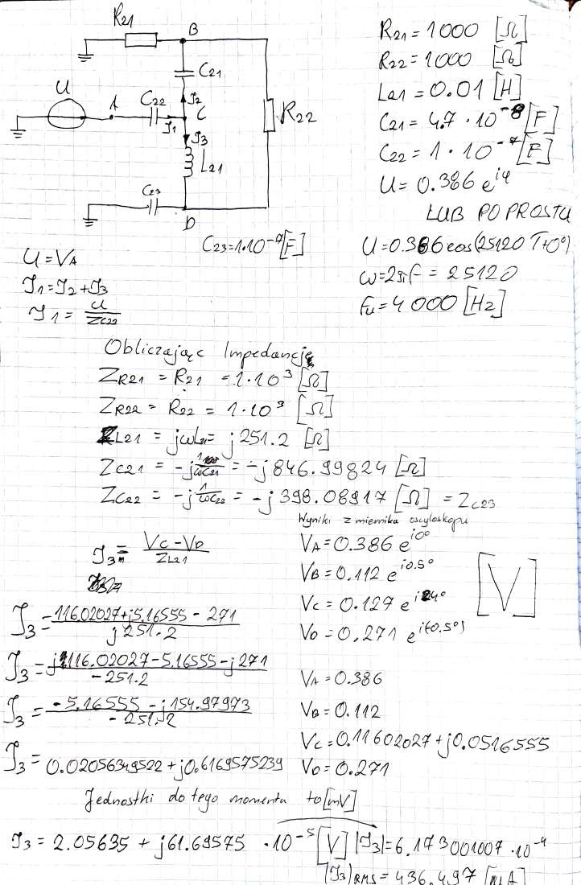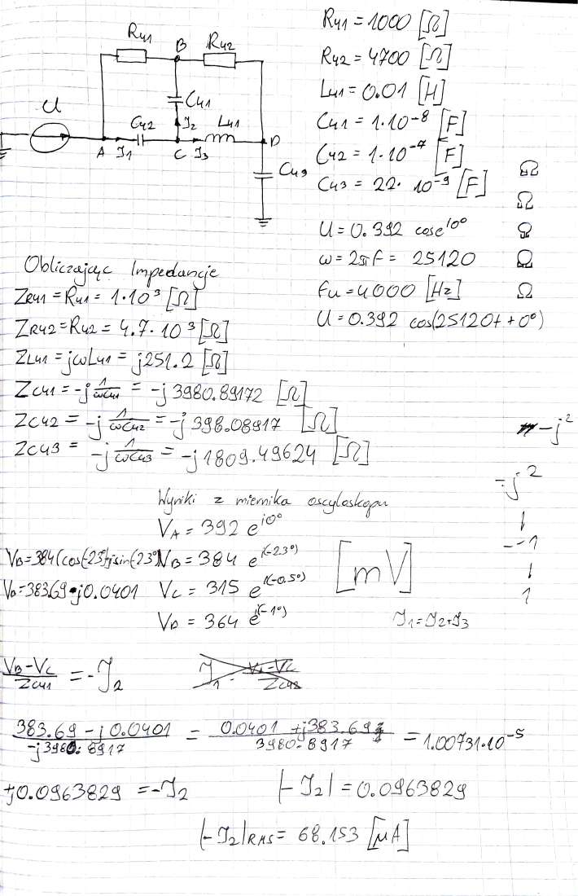

1. Analyzing circuits in MathLab
   1. We have written simple MathLab tool to solve circuits B and D. In result we have gotten following results (we only used source voltage for calculations):
      1. Circuit B node voltages:

|  |  |  |  |  |
| --- | --- | --- | --- | --- |
| Frequency = 4kHz | U [mV] | angle | Measured values / U [mV] | angle |
| 1 | 386 | 0 | 386 | 0 |
| 2 | 111 | -7.87 | 112 | 0,5 |
| 3 | 110 | 17.72 | 127 | 24 |
| 4 | 279 | -4.87 | 271 | -0,5 |

|  |  |  |  |  |
| --- | --- | --- | --- | --- |
| Frequency = 6kHz | U [mV] | angle | Measured values / U [mV] | angle |
| 1 | 386 | 0 | 340 | 0 |
| 2 | 165 | 180 | 116 | -138 |
| 3 | 315 | 79.32 | 290 | 85 |
| 4 | 449 | -61.35 | 465 | -43,3 |

|  |  |  |  |  |
| --- | --- | --- | --- | --- |
| Frequency = 8kHz | U [mV] | angle | Measured values / U [mV] | angle |
| 1 | 386 | 0 | 345 | 0 |
| 2 | 259 | 78.87 | 244 | 91 |
| 3 | 377 | 28.04 | 425 | 29,5 |
| 4 | 179 | -117.1 | 228 | -111 |

* + 1. Circuit D node voltages:

|  |  |  |  |  |
| --- | --- | --- | --- | --- |
| Frequency = 4kHz | U [mV] | angle | Measured values / U [mV] | angle |
| 1 | 391 | -1.48 | 392 | 0 |
| 2 | 385 | -3.64 | 384 | -2,3 |
| 3 | 316 | -1.90 | 315 | -0,5 |
| 4 | 368 | -1.73 | 364 | -1 |

|  |  |  |  |  |
| --- | --- | --- | --- | --- |
| Frequency = 6kHz | U [mV] | angle | Measured values / U [mV] | angle |
| 1 | 390 | -2.67 | 391 | 0 |
| 2 | 391 | -6.85 | 390 | -4 |
| 3 | 300 | -2.50 | 302 | 0,5 |
| 4 | 440 | -3.27 | 429 | -2 |

|  |  |  |  |  |
| --- | --- | --- | --- | --- |
| Frequency = 8kHz | U [mV] | angle | Measured values / U [mV] | angle |
| 1 | 385 | -4.921 | 389 | 0 |
| 2 | 400 | -13.48 | 396 | -8 |
| 3 | 265 | -3.04 | 273 | 3 |
| 4 | 604 | -7.81 | 564 | -5 |

* + 1. Calculating current across L21 and C41:

|  |  |  |  |  |
| --- | --- | --- | --- | --- |
| Frequency  [kHz] | L21 expected  [micro A] | L21 measured  [micro A] | C41 expected | C41 measured |
| 4 | -0.0002- 0.0006i | -0.0001 - 0.0003i | -3.182e-06 - 1.726e-05i | -3.519e-06 - 1.716e-05i |
| 6 | -0.0018 - 0.0004i | -0.0012 - 0.0006i | -7.499e-06 - 2.18e-05i | -1.264-05 - 3.302-05i |
| 8 | -0.0006 + 0.0008i | -0.0008 + 0.0008i | -1.744e-05 - 3.003e-05i | -3.982-05 - 6.257-05i |

1. Results gotten from MultiSim:
   1. Circuit B:

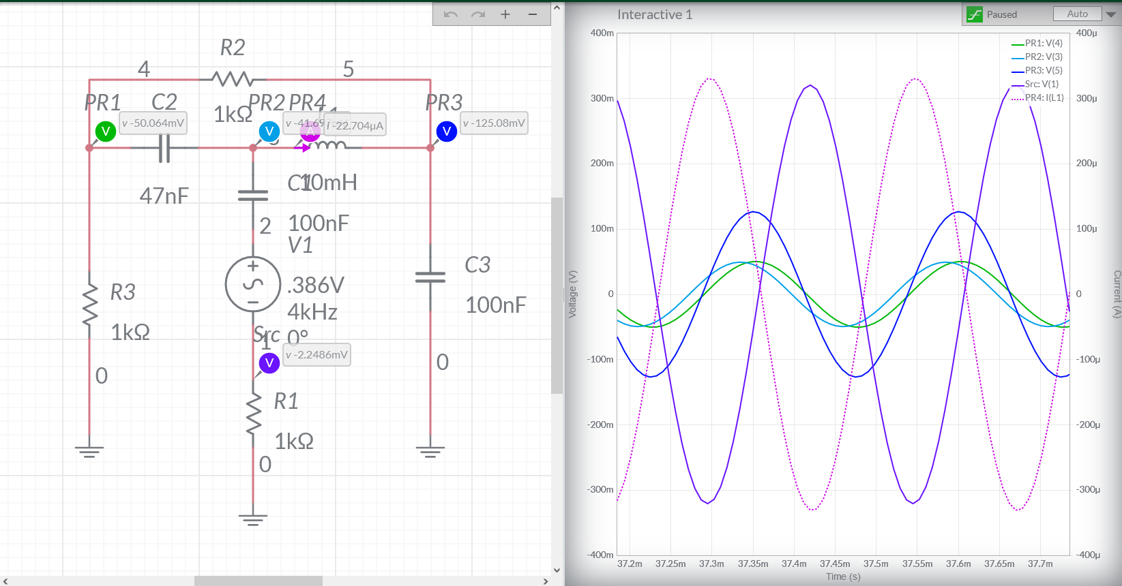

* 1. Circuit D:

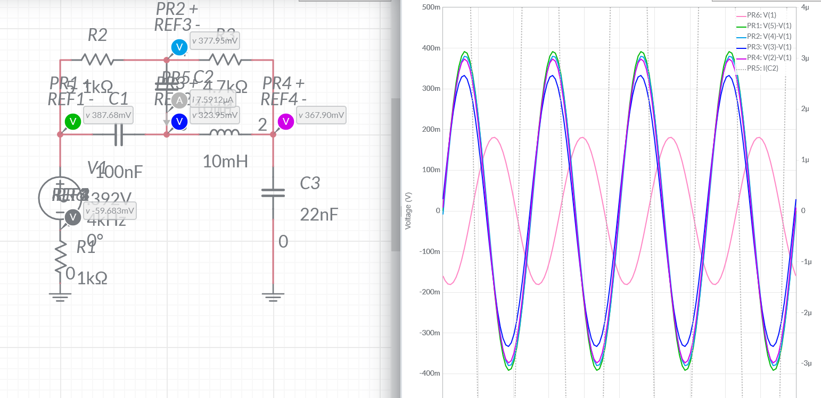

1. Conclusion:

Trying to solve even such simple circuits by hand is a chore so it is better to use software to calculate needed values. Although results from circuit B are not as correlated with measured values, our D results are pretty much spot on. When it comes to calculate current value across components our results got closer to simulated solution than to real one but that is most likely measurement issue or physical component value inaccuracy.

1. Codebase (all files can be found on ):
   1. Functions changing capacitance and inductance into reactance. Also omega calculation function:



* 1. Circuit D code

% circuit 2 to solve nodal

% -----R41/1000/ ----B----- R42/4700/------

% | | |

% | | |

% | C41/10nF/ |

% | | |

% A----C42/100nF/----C------L41/10mH/------D

% | |

% R/50/ |

% U// C43/22nF/

% | |

% GND GND

% looking for voltages A, B, C, D

% eq A: U_a(1/R50 + 1/Xc42 + 1/R41) - U_b(1/r41) - U_c(1/Xc42) -U_d(0) =

% = U_src/R50

% eq B: -U_a(1/R41) + U_b (1/R41 + 1/Xc41 + 1/R42) - U_c (1/Xc41) -

% U_d(1/R42) = 0

% eq C: -U_a(1/Xc42) - U_b (1/Xc41) + U_c (1/Xc42 + 1/Xc41 +1/ Xl41) -

% U_d(1/Xl41) = 0

% eq D: -U_a(0) - U_b (1/R42) - U_c (1/Xl41) + U_d(1/R42 +1/Xl41 + 1/Xc43) = 0

%Frequencies 4kHz, 6kHz, 8kHz

% voltages = .392, .391, .389 V

% we can form matrix equation G*U=A

% preperation:

matrix_G = complex(zeros(4,4,3));

matrix_I = complex(zeros(4,1,3));

matrix_V = complex(zeros(4,1,3));

detG = [0 0 0];

detA = [0 0 0];

detB = [0 0 0];

detC = [0 0 0];

detD = [0 0 0];

U_a = [0 0 0];

U_b = [0 0 0];

U_c = [0 0 0];

U_d = [0 0 0];

X_r_50 = [50 50 50 50];

X_r_41 = [1000 1000 1000];

X_r_42 = [4700 4700 4700];

X_c_41 = [10*10^-9 10*10^-9 10*10^-9];

X_c_42 = [10^-7 10^-7 10^-7];

X_c_43 = [22*10^-9 22*10^-9 22*10^-9];

X_l_41 = [0.01 0.01 0.01];

I_C_41 = [0 0 0];

freq = [4000 6000 8000];

U_src = [.392 .391 .389];

omega = [calc_omega(freq(1)) calc_omega(freq(2)) calc_omega(freq(3))];

for i = 1:3

X_c_41 (:,i) = Zc(omega(:,i),X_c_41(:,i));

X_c_42 (:,i) = Zc(omega(:,i),X_c_42(:,i));

X_c_43 (:,i) = Zc(omega(:,i),X_c_43(:,i));

X_l_41 (:,i) = Zl(omega(:,i),X_l_41(:,i));

end

% eq A: U_a(1/R50 + 1/Xc42 + 1/R41) - U_b(1/r41) - U_c(1/Xc42) -U_d(0) =

% = U_src/R50

% eq B: -U_a(1/R41) + U_b (1/R41 + 1/Xc41 + 1/R42) - U_c (1/Xc41) -

% U_d(1/R42) = 0

% eq C: -U_a(1/Xc42) - U_b (1/Xc41) + U_c (1/Xc42 + 1/Xc41 +1/ Xl41) -

% U_d(1/Xl41) = 0

% eq D: -U_a(0) - U_b (1/R42) - U_c (1/Xl41) + U_d(1/R42 +1/Xl41 + 1/Xc43) = 0

for i = 1:3

matrix_G(:,:,i) = [

(1/X_r_50(i) + 1/X_c_42(i) + 1/X_r_41(i)) -(1/X_r_41(i)) -(1/X_c_42(i)) -(0);

-(1/X_r_41(i)) (1/X_r_41(i) + 1/X_c_41(i) + 1/X_r_42(i)) -(1/X_c_41(i)) -(1/X_r_42(i));

-(1/X_c_42(i)) -(1/X_c_41(i)) (1/X_c_42(i) + 1/X_c_41(i) +1/X_l_41(i)) -(1/X_l_41(i));

-(0) -(1/X_r_42(i)) -(1/X_l_41(i)) (1/X_r_42(i) +1/X_l_41(i) + 1/X_c_43(i)) ];

end

for i=1:3

matrix_I(:,:,i) = [

U_src(i)/X_r_50(i);

0;

0;

0];

end

matr_A = matrix_G;

matr_A(:,1,:) = matrix_I(:,1,:);

matr_B = matrix_G;

matr_B(:,2,:) = matrix_I(:,1,:);

matr_C = matrix_G;

matr_C(:,3,:) = matrix_I(:,1,:);

matr_D = matrix_G;

matr_D(:,4,:) = matrix_I(:,1,:);

for i = 1:3

detG(i) = det(matrix_G(:,:,i));

detA(i) = det(matr_A(:,:,i));

detB(i) = det(matr_B(:,:,i));

detC(i) = det(matr_C(:,:,i));

detD(i) = det(matr_D(:,:,i));

end

for i =1:3

U_a(i) = detA(i)/detG(i);

U_b(i) = detB(i)/detG(i);

U_c(i) = detC(i)/detG(i);

U_d(i) = detD(i)/detG(i);

end

%calculating voltage drop accros C41

rmsA = [abs(U_a(1)) rad2deg(angle(U_a(1)));

abs(U_a(2)) rad2deg(angle(U_a(2)));

abs(U_a(3)) rad2deg(angle(U_a(3)));

];

rmsB = [abs(U_b(1)) rad2deg(angle(U_b(1)));

abs(U_b(2)) rad2deg(angle(U_b(2)));

abs(U_b(3)) rad2deg(angle(U_b(3)));

];

rmsC = [abs(U_c(1)) rad2deg(angle(U_c(1)));

abs(U_c(2)) rad2deg(angle(U_c(2)));

abs(U_c(3)) rad2deg(angle(U_c(3)));

];

rmsD = [abs(U_d(1)) rad2deg(angle(U_d(1)));

abs(U_d(2)) rad2deg(angle(U_d(2)));

abs(U_d(3)) rad2deg(angle(U_d(3)));

];

%expected values

for i =1:3

I_C_41(i) = (U_c(i)-U_b(i))/(X_c_41(i));

end

%measured values:

U_m_B = [.384*exp(deg2rad(-2.3)*j);

.390*exp(deg2rad(-4)*j);

.396*exp(deg2rad(-8)*j) ];

U_m_C = [.315*exp( deg2rad(-.5)*j);

.302*exp( deg2rad(.5)*j);

.273*exp( deg2rad(3)*j) ];

expected_c_41 = (U_m_C(:,:) - U_m_B(:,:));

expected_c_41 = expected_c_41(:)/X_c_41(:);

* 1. Circuit B:

% circuit 1 to solve nodal

% ----------------R22/1000/--------------

% | |

% | |

% | |

% X---C21/47*10^-9F/---Y----L21/0.01H/----Z

% | | |

% | | |

% R21/1000/ C22/10^-7F/ C23/10^-7F/

% | | |

% | A |

% | | |

% | U/0.386V |

% | | |

% | R50 |

% | | |

% GND GND GND

% eq A: U_a=U_src, skiped as it provides nothing

% eq X: U_x(1/R21+1/XC21+1/R22) - U_y(1/XC21) - U_z(1/R22) = 0

% eq Y: - U_x(1/XC21) + U_y(1/XC21 + 1/(XC22 + R50) + 1/XL21) - U_z(1/XL21) =

% = U/(XC22 + R50)

% eq Z: - U_x(1/R22) - U_y(1/XL21) + U_z(1/R22 + 1/XL21 + 1/XC23) = 0

% frequencies 4k, 6k, 8k

% voltages = .386, .340, .345 V

% we can form matrix equation G*U=A

% preperation:

matrix_G = complex(zeros(3,3,3));

matrix_I = complex(zeros(3,1,3));

matrix_V = complex(zeros(3,1,3));

detG = [0 0 0];

detX = [0 0 0];

detY = [0 0 0];

detZ = [0 0 0];

U_x = [0 0 0];

U_y = [0 0 0];

U_z = [0 0 0];

X_r_50 = [50 50 50];

X_r_22 = [1000 1000 1000];

X_r_21 = [1000 1000 1000];

X_c_21 = [47*10^-9 47*10^-9 47*10^-9];

X_c_22 = [10^-7 10^-7 10^-7];

X_c_23 = [10^-7 10^-7 10^-7];

X_l_21 = [0.01 0.01 0.01];

I_l_21 = [0 0 0];

freq = [4000 6000 8000];

U_src = [.386 .340 .345];

% calc omega from frequencies

omega = [calc_omega(freq(1)) calc_omega(freq(2)) calc_omega(freq(3))];

omega = [calc_omega(freq(1)) calc_omega(freq(2)) calc_omega(freq(3))];

% calc complex resistance from incuctance and cappacitance

for i = 1:3

X_c_21 (:,i) = Zc(omega(:,i),X_c_21(:,i));

X_c_22 (:,i) = Zc(omega(:,i),X_c_22(:,i));

X_c_23 (:,i) = Zc(omega(:,i),X_c_23(:,i));

X_l_21 (:,i) = Zl(omega(:,i),X_l_21(:,i));

end

% eq A: U_a=U_src, skiped as it provides nothing

% eq X: U_x(1/R21+1/XC21+1/R22) - U_y(1/XC21) - U_z(1/R22) = 0

% eq Y: - U_x(1/XC21) + U_y(1/XC21 + 1/(XC22 + R50) + 1/XL21) - U_z(1/XL21) =

% = U/(XC22 + R50)

% eq Z: - U_x(1/R22) - U_y(1/XL21) + U_z(1/R22 + 1/XL21 + 1/XC23) = 0

% constructing matrix G that is 3x3 because A contributes "nothing":

for i = 1:3

matrix_G(:,:,i) = [

((1/X_r_21(i)) + (1/X_c_21(i)) + (1/X_r_22(i))) -(1/X_c_21(i)) -(1/X_r_22(i));

-(1/X_c_21(i)) ((1/X_c_21(i)) + (1/(X_c_22(i) + X_r_50(i))) + (1/X_l_21(i))) -(1/X_l_21(i));

-(1/X_r_22(i)) -(1/X_l_21(i)) ((1/X_r_22(i))+(1/X_l_21(i))+ (1/X_c_23(i)))

];

end

for i=1:3

matrix_I(:,:,i) = [

0;

(U_src(i)/(X_c_22(i)+X_r_50(i)));

0];

end

%prep for det's, remember we only move in frequency domain!!!!

matr_X = matrix_G;

matr_X(:,1,:) = matrix_I(:,1,:);

matr_Y = matrix_G;

matr_Y(:,2,:) = matrix_I(:,1,:);

matr_Z = matrix_G;

matr_Z(:,3,:) = matrix_I(:,1,:);

for i = 1:3

detG(i) = det(matrix_G(:,:,i));

detX(i) = det(matr_X(:,:,i));

detY(i) = det(matr_Y(:,:,i));

detZ(i) = det(matr_Z(:,:,i));

end

%calculate voltages in nodes:

for i =1:3

U_x(i) = detX(i)/detG(i);

U_y(i) = detY(i)/detG(i);

U_z(i) = detZ(i)/detG(i);

end

%calculating voltage drop accros L21

rmsX = [abs(U_x(1)) rad2deg(angle(U_x(1)));

abs(U_x(2)) rad2deg(angle(U_x(2)));

abs(U_x(3)) rad2deg(angle(U_x(3)))

];

rmsY = [abs(U_y(1)) rad2deg(angle(U_y(1)));

abs(U_y(2)) rad2deg(angle(U_y(2)));

abs(U_y(3)) rad2deg(angle(U_y(3)))

];

rmsZ = [abs(U_z(1)) rad2deg(angle(U_z(1)));

abs(U_z(2)) rad2deg(angle(U_z(2)));

abs(U_z(3)) rad2deg(angle(U_z(3)))

];

%expected values

for i =1:3

I_l_21(i) = (U_z(i)-U_y(i))/(X_l_21(i));

end

%measured values:

U_m_Y = [.127*exp(deg2rad(24)*j);

.290*exp(deg2rad(85)*j);

.425*exp(deg2rad(29.5)*j) ];

U_m_Z = [.271*exp( deg2rad(-.5)*j);

.465*exp( deg2rad(-43.5)*j);

.228*exp( deg2rad(-111)*j) ];

expected_l_21 = (U_m_Z(:,:) - U_m_Y(:,:));

expected_l_21 = expected_l_21(:)/X_l_21(:);